A000-Eur**-Germany-Vogelherdhöhle-Figurine-***Panthera leo spelaea* (Cave-Lion)-**Ivory-Mid Paleolithic-ca 40**-29 kya

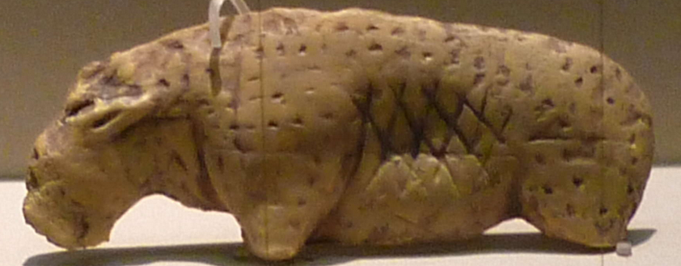

**Fig. 1. Germany-Vogelherdhöhle-Figurine-** *Panthera leo spelaea* (Eurasian Cave-Lion) **Ivory-Middle Paleolithic-ca 40,000 BP-**29,000 BP, original.

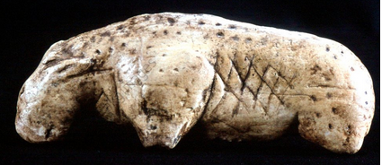

Fig. 2. **Germany-Vogelherdhöhle-Figurine-***Panthera leo spelaea* (Eurasian Cave-Lion) **Ivory-Middle Paleolithic-ca 40,000 BP-**29,000 BP, replica in resin.

**Formal Label:** Eur**-Germany-Vogelherdhöhle-Figurine-***Panthera leo spelaea* (Cave-Lion)-**Ivory-Mid Paleolithic-ca 40**-29 kya

**Display description:** Vogelherdhöhle (“Bird-Heart Cave”) is located on a sloping limestone ledge with a strategic view of the Lone River Valley. This figurine of a pregnant *Panthera leo spelaea* (Eurasian Cave-Lion) has been sculpted perhaps for the purpose of instructing novice hunters the best game to pursue. The attention of the artist to depict this animal in a pose that suggests that it is drinking water is appropriate to the time when the hunter should act. Engraved cross marks on the left flank may indicate the area a hunter should look to determine whether the animal is pregnant. Here it clearly shows the full belly and the unborn foetus shape.

**Accession Number:**

**LC Classification:** GN772.2.A8

**Date or Time Horizon:** 40,000 BP-29,000 BP

**Geographical Area: Vogelherdhöhle Site, Germany**

**Map, GPS Coordinates:** 48.561321, 10.189116

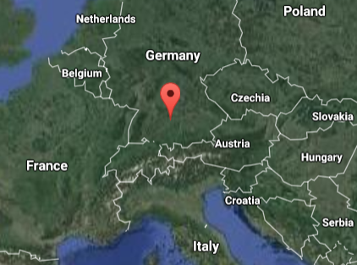

Fig. 2. Location of Vogelherdhöhle in the local landscape.

Fig. 3. Location of Vogelherdhöhle in Germany.

**Cultural Affiliation:** Aurignacian, *Homo sapiens sapiens*

**Medium:** original, mammoth ivory; museum replica in resin.

**Dimensions: original, L** 4.8 cm **Weight: original, n/a.**

**Provenance: original,** Museum Schloss Hohentübingen, **Tübingen.**

**Condition:** museum replica in resin**.**

**Discussion:**

On 23 May 1931 Hermann Mohn, a private researcher from Heidenheim, while probing the hills near Stetten bei Niederstotzingen for prehistoric remains, found flint artifacts in the rear of a badger den, which he named “Mohnloch” (“Mohn’s hole”). He informed the prehistory department of the University of Tübingen of a potential Paleolithic cave, and Tübingen sent a junior researcher, Gustav Riek, to Stetten to inspect the site. The Y-shaped cave has three openings (S, SW and N) and covers 170 m2. Mohn and Riek squeezed through the 30 cm x 40 cm opening into the badger den and on the evening of the second day they found the Paleolithic evidence they were looking for: Mohn’s hunch was right, and when this was confirmed Tübingen renamed the cave “Vogelherdhöhle,” “Bird-Heart Cave,” for the way the waters of the Lone River attracted birds and for the cave’s three cavities that resembled the three chambers of a heart. Then, Riek excavated the entire cave in just three months. Small artifacts escaped detection and were jettisoned into large back-fill mounds. In subsequent years these mounds have been thoroughly re-examined and many discarded artifacts have been recovered, but they were now without any contextual information.

Vogelherdhöhle has four Middle Paleolithic strata and four Upper Paleolithic strata of which two layers V and VI belong to the Aurignacian, in which eleven figurines, like the present artifact, were found. Two other cultural strata include the Magdalenian and the Neolithic but the Gravettian is missing. The lower Aurignacian layer V supplied a total of seven figurines, including those of an *Equus ferus przewalskii*  (Przewalski’s horse), a small mammoth, a large mammoth (of which only the rear part and the front leg and neck area were recovered), a headless animal figurine, a *Panthera leo spelaea* (Eurasian Cave-Lion) and an unidentified headless animal with its head now discovered from the excavations in 2012 (Conard et al., 2013). Four figurines from the upper layer IV include a *Panthera leo spelaea*, a *Bison priscus* (Steppe Bison), a mammoth and an anthropomorph. Although the layer in which each figurine was excavated is known, Riek had not recorded their exact positions and their contexts.

**References:**

Bosinski, G. 2013. “Les precurseurs de l'art aurignacien.” In P. Bodu, L. Chehmana, L Klaric, L. Mevel, S. Soriano and N. Teyssandier, N. (eds.), *Le Paleolithique superieur ancien de /'Europe du Nord-Ouest: Reflexions et syntheses a partir d'un projet collectif de* *récherche sur le centre et le sud du Bassin parisien: Actes du colloque de Sens (15-18 avril 2009)* Paris: Sociéte préhistorique française.

Conard, N. J., Zeidi, M. and Bega, J. 2013. “Die letzte Kampagne *der* Nachgrabungen am Vogelherd,” *Archaologische Ausgrabungen in Baden-Wurttemberg,* 2012: 84-88.

Delporte, H. 1990. *L'image des animaux dans l'art préhistorique,* Paris: Picard.

Delporte, H. 1993. *L'image de la femme dans l'art préhistorique. Nouvelle edition augmentée,* Paris, Picard.

Hahn, J. 1970. “Die Stellung der mannlichen Elfenbeinstatuette aus dem Höhlenstein-Stadel in der jungpaläolithischen Kunst,” *Germania,* 48: 1-12.

Hahn, J., Muller-Beck, H. and Taute, W. 1985. *Eiszeithöhlen im Lonetal.* Stuttgart: Konrad Theiss Verlag.

Leroi-Gourhan Arlette, J. Allain, and **L. Balout**, eds. 1979. *Lascaux inconnu.* Paris: Éditions du Centre national de la récherche scientifique.

Niven, Laura. 2006. The Palaeolithic Occupation of Vogelherd Cave: Implications for the Subsistence Behavior of Late Neanderthals and Early Modern Humans. Tübingen: Kerns.

Riek, Gustav. 1934. *Die Eiszeitjägerstation am Vogelherd im Lonetal*, Bd. I: Die Kulturen. Leipzig: Kabitzsch.

Riek, Gustav. 1935. *Kulturbilder aus der Altsteinzeit Württembergs*. Tübingen: Franz F. Heine.